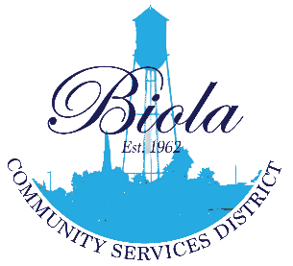*Biola Community Services District*

**Minutes of the**

**Board of Directors**

**Regular Board Meeting August 21, 2025**

**6:00p.m.**

**CANCELLED DUE TO LACK OF QUORUM**

The Board of Directors of the Biola Community Services District met for its Regular Board Meeting on August 21, 2025 at the Biola Community Center, Biola, California.

**Directors present: Eugenio Gutierrez – Vice President**

**Carlos Rodriguez – Board Member**

**Directors absent: Kinverly Suarez – President**

**Monique Dolores – Board Member**

**Staff Present:** **Present along with legal counsel and Spanish translators.**

**Public present:** **Present**

At 6:15 PM, Vice President Eugenio Gutierrez announced that the meeting was canceled due to the lack of quorum.

I, Carmen Zamora, Board Clerk to the Board for the Community of Biola, do hereby declare under penalty of perjury that the above Minutes are a true report of all action minutes taken at the Regular Board of Directors meeting held on March 20, 2025 at the Biola Community Services District, 4925 Seventh Street, Biola, CA 93606.

Approved:

_________________ ______________________________

Date Carmen Zamora, Board Clerk

**NEXT MEETING OF THE BOARD OF DIRECTORS**

**September 18, 2025 – Regular Meeting, Biola CA at 6:00PM**